**Effect of State Regulations on Opioid Shipment and Overdose Deaths**

Xiaoyu Chen, Raza Lamb, Roza Ogurlu, Robert Wan

1. **Introduction**

**1.1** The motivation for the project:

Social policies play an essential role in regulating people's lives and the development of society. The motivation for this project is to quantify the impact of state policy changes in comparison to places where such policy changes didn't take place, to determine whether and to what extent these policies have addressed the current problems, and whether the policy changes can inform the development of more effective policies in the future. The context of this project is the increase in drug addiction and prescription opioid overdose deaths in the US in the past two decades. In this project, we'll measure the effect of a series of policy changes designed to limit abuse of prescription opioid drugs and mortality from drug overdoses. Three policies we will be focusing on were effective in Florida, Texas, and Washington in 2010, 2007 and 2012, respectively.

**1.2** The motivation for the research design being used:

The research design that we're implementing should show us if the policy changes in Florida, Texas, and Washington affected the number of deaths related to opioid abuse and the number of prescription opioids shipped into the state. Therefore, the motivation for the research design is to establish a causal relationship between policy change and opioid abuse parameters. We will achieve this by using two strategies in tandem: pre-post comparison and difference-in-difference analysis. Pre-post comparison will show us what opioid abuse parameters look like beforehand after the policy change. In difference-in-difference analysis, we will compare the pre- and post-periods in policy state of interest to a control group with no policy change. This analysis will eliminate the causal effects of changes other than the policy change that could lead us to misinterpretation the result.

* 1. Details of the data used and how different datasets have been related to one another:

Three datasets that were used in the analysis were:

* All opioid prescription drug shipments in the US from 2006-2012 (from US Drug Enforcement Agency, requested by Washington Post).
* Mortality due to drug and non-drug-related causes in the US from 2003-2015 (from US Vital Statistics records).
* Population and population estimates for each US county from 2003-2015 (from US Census).

The opioid shipment data had detailed information for each transaction that happened, including buyer/reporter, drug type/dose, date. From these, we kept transaction date, buyer state/county/zip, drug code/name, the total active weight of drug, dosage unit, drug morphine equivalent, and dose strength in milligrams. We decided to use total active weight in grams (CALC_BASE_WT_IN_GM) to represent opioid shipment for each transaction. To get the final data frame, we grouped the selected columns by transaction year, buyer country, and CALC_BASE_WT_IN_GM.

For the mortality dataset, we read data for each year in separate excel sheets. We subseted data for Drug/Alcohol-related deaths in category D. We grouped data by State, County, Year, and summed occurrences in these groups.

For the population data, we used data from US Census in 2000 and 2010. We constructed a data frame with population count for years available and population estimates for the remaining years from 2003-2015. The final data frame had state, county, year, population columns. After cleaning three datasets, we merged the population data frame to both mortality and opioid shipment.

We performed a 1:1 outer merge of population and mortality datasets on state, county, and year. Counts that did not have observations for 13 years did not seem worthy of being added to this discussion, while those that had values in some years, we kept them and filled the remaining nulls with 0s. We also performed a 1:1 outer merge between populations and shipment datasets on state, county, year. We dropped non-mainland regions and filled in nulls with 0s. Once we had the two merged datasets, we subsisted both for each policy state and others. We also added an indicator variable showing if the observation was pre or post-policy and normalized data by population. These final datasets were used for analysis.

* 1. Summary Statistics

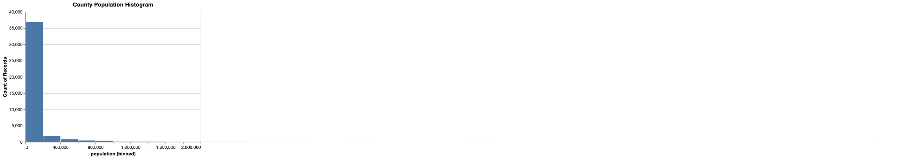

Histogram 1 county population

Histogram 3 Florida shipment

Histogram 2 Florida mortality

Histogram 5 Washington shipment

Histogram 4 Washington mortality

Histogram 7 Texas shipment

Histogram 6 Texas mortality

Histograms above are to help visualize the distribution of each dataset used in the pre-post and difference-in-difference analyses and include observations for each year-county. One addition to the state specific datasets is the population dataset, which we added here as a point of reference and which we used for normalizing our opioid shipment and mortality data frames. County population histogram (Histogram 1) indicates that most counties have populations < 200k in 2003-2015. Some outliers were excluded from the histogram.

State specific histograms display opioid abuse quantifier (shipment or mortality) counts normalized by population of the county in observation year. All state specific histograms, other than Washington shipment, have many counts on towards the origin. This is the result of null values that we replaced with 0s in our cleaned datasets prior to population normalization. Except for this trend, values seem to be right-skewed and non-uniformly distributed for all datasets.

Below are statistical value tables for state specific datasets and the population dataset we used for normalization. Again, one observation from the statistical data is the sheer number of zeros in the datasets. For instance, in Texas mortality data, 0s make at least 75% of the data. This effect reduces the mean.

**Descriptive Statistics for Mortality, Florida**

|  | **Deaths** | **Deaths per 100k Population** |
| --- | --- | --- |
| **Count** | 871 | 871 |
| **Mean** | 37.1515 | 7.72725 |
| **St Dev** | 63.6241 | 8.61573 |
| **Min** | 0 | 0 |
| **25%** | 0 | 0 |
| **50%** | 11 | 5.8194 |
| **75%** | 40.5 | 14.4503 |
| **Max** | 326 | 40.8222 |

**Descriptive Statistics for Mortality, Washington**

|  | **Deaths** | **Deaths per 100k Population** |
| --- | --- | --- |
| **Count** | 507 | 507 |
| **Mean** | 20.1815 | 5.2927 |
| **St Dev** | 48.4278 | 7.34506 |
| **Min** | 0 | 0 |
| **25%** | 0 | 0 |
| **50%** | 0 | 0 |
| **75%** | 16 | 11.1949 |
| **Max** | 309 | 30.685 |

**Descriptive Statistics for Mortality, Texas**

|  | **Deaths** | **Deaths per 100k Population** |
| --- | --- | --- |
| **Count** | 3302 | 3302 |
| **Mean** | 6.8722 | 1.34844 |
| **St Dev** | 35.0037 | 3.99708 |
| **Min** | 0 | 0 |
| **25%** | 0 | 0 |
| **50%** | 0 | 0 |
| **75%** | 0 | 0 |
| **Max** | 528 | 42.7442 |

**Descriptive Statistics for Shipment, Florida**

|  | **Shipment (kg)** | **Shipment (kg) per 100k Population** |
| --- | --- | --- |
| **Count** | 469 | 469 |
| **Mean** | 135678 | 38.416 |
| **St Dev** | 264159 | 23.074 |
| **Min** | 0 | 0 |
| **25%** | 7496.24 | 21.442 |
| **50%** | 40796.2 | 34.452 |
| **75%** | 132909 | 49.006 |
| **Max** | 2.05341e+06 | 154.465 |

**Descriptive Statistics for Shipment, Washington**

|  | **Shipment (kg)** | **Shipment (kg) per 100k Population** |
| --- | --- | --- |
| **Count** | 273 | 273 |
| **Mean** | 45761.3 | 28.125 |
| **St Dev** | 83927.1 | 11.835 |
| **Min** | 624.668 | 8.254 |
| **25%** | 5571.12 | 19.195 |
| **50%** | 14958.9 | 25.035 |
| **75%** | 38687 | 35.084 |
| **Max** | 471707 | 64.950 |

**Descriptive Statistics for Shipment, Texas**

|  | **Shipment (kg)** | **Shipment (kg) per 100k Population** |
| --- | --- | --- |
| **Count** | 1778 | 1778 |
| **Mean** | 18168 | 15.764 |
| **St Dev** | 71776.5 | 11.191 |
| **Min** | 0 | 0 |
| **25%** | 654.729 | 7.752 |
| **50%** | 2590.75 | 14.555 |
| **75%** | 10757.3 | 22.542 |
| **Max** | 1.10302e+06 | 75.425 |

**Descriptive Statistics for US Population**

|  | **Population per County** |
| --- | --- |
| **Count** | 40853 |
| **Mean** | 97386.9 |
| **St Dev** | 312310 |
| **Min** | 55 |
| **25%** | 11061 |
| **50%** | 25580 |
| **75%** | 65964 |
| **Max** | 1.00854e+07 |

## **Analysis Methods:**

2.1 Summary

We employed two methodologies to investigate the effect of opioid drug prescription regulations on the volume of opioids prescribed and drug overdose deaths. First, we compared the metrics before and after the regulations went into effect in each state. Next, we performed difference-in-difference analyses to account for nationwide factors that might have influenced the values of the metrics so that we can more accurately quantify the effect of the regulation changes.

2.2 Pre-Post Comparison

We first performed a pre vs. post analysis to compare the volume of opioids shipped, and the number of drug overdose deaths before and after the policy regulations took effect. Since we did not have access to data on opioid prescriptions, we used opioid shipment as a proxy for opioid prescriptions.

2.2.1 Time Period

The pre-period of each analysis includes all years before the regulation took effect in the state. The year that the regulation took effect and onwards are the post-period. Each of the three states we investigated implemented regulations in different years. In addition, the opioid shipment and drug overdose death data sets we used to cover different time periods. As such, the pre-and post-periods for each analysis are different.

We have laid out the pre-and post-periods for each analysis below to clarify the periods of each analysis.

Table 1 periods of each analysis

2.2.2 Methodology

We created an indicator variable for each analysis that would mark whether each observation was from the pre-period or the post-period. We then ran linear regressions for the pre-period and the post-period separately, using year as the independent variable and the metric of interest of the analysis (shipment or overdose death) as the dependent variable. We also calculated the 95% confidence interval for each regression.

To visualize the effect of regulation, we plotted the regression line and the confidence band of the pre-period and those of the post-period on the same plot. In each plot, the x-axis represents the year, and the y-axis represents the metric of interest.

Opioid shipment and overdose death increased the Florida, Texas, and Washington before the regulations took effect. As such, if opioid regulations did positively affect opioid prescriptions or overdose death, we'd expect the post-period regression line to have a smaller slope than the pre-period regression line. If the post-period and pre-period slopes are similar, then the regulations likely did not have a meaningful impact.

2.3 Difference-in-Difference

The pre-post comparison method described above is an easy and straightforward way to visualize the effect of regulation of opioids. However, it is difficult to attribute the pre- vs. post-period slopes changes to the rules because the method does not account for potential confounders.

To overcome this limitation, we next performed a difference-in-difference analysis, in which we compared the counties in Florida, Texas, and Washington to similar counties in other states. This method assumes that counties in Florida, Texas, and Washington would behave comparable to similar counties in other states. Therefore, similar counties could provide insights into what would have happened in Florida, Texas, and Washington had the regulations not taken place. To make things easier, we'll refer to counties in each of Florida, Texas, and Washington as a "test group," and the group of similar counties selected for each test group, the "control group." The process we used to determine the control group for each test group is described below.

2.4 Control Group Selection

To ensure that the difference-in-difference methodology measures the effect of regulations instead of the effects of confounders, we'd need to find control counties that are as similar to the test group as possible. Most importantly, we must ensure that the control group has an equal pre-period slope as the test group. To achieve this, we used the below process to select control counties for each test group.

1. Calculate the pre-period slope of the measured metric (shipment/mortality) for counties in the test group and counties in the rest of the country

2. Calculate the pre-period average population of counties in the test group and counties in the rest of the country

3. For each county in the test group, select two counties in the control group whose pre-period slope is the most similar to that of the test county

4. If there are ties, narrow down to 2 counties whose pre-period average population is the most similar to that of the test county

5. Draw with replacement

Following the process above, we selected two similar counties for each county in the three test groups. Counties were first selected based on the pre-period slope of the measured metric. There were many counties in the test groups whose pre-period slope was 0 – for those counties. We selected control counties whose pre-period slope was also 0 and who had a similar population as the test county.

We drew with replacement so that if a particular county were selected as the control multiple times, then we'd give the county a higher weight in the control group accordingly.

2.4.1 Time Period

The pre-and post-period of each analysis is the same as the time periods listed out in the table under the previous section. For each analysis, we used the same time periods for the test group and the control group.

2.4.2 Methodology

Similar to the pre-post comparison analysis, we created an indicator variable to mark whether an observation was from the pre-period or the post-period. In each analysis, we ran four regressions, one each for the test and control groups in the pre-and post-periods. We then plotted the regression lines and as well as the confidence bands using a 95% confidence level.

We plotted each analysis in a separate plot. On each plot, there are four lines – test group in the pre-period, test group in the post-period, control group in the pre-period, and control group in the post-period. To distinguish the test group from the control group, we applied different colors for each group. If we had performed the control selection appropriately, we'd expect to see similar slopes for the regression lines of the test group and the control group in the pre-period. If the regulation had a meaningful impact on the opioid shipment or overdose death, then we'd expect the slope of the test group in the post-period to decrease while the slope of the control group in the post-period remains constant or decreases by a smaller magnitude.

1. **Analysis Results**

3.1 Pre-Post Analysis

Initially, we conducted our pre-post analysis, simply looking at the trend in either opioid prescription shipments or opioid overdoses in states with a policy change before and after that policy change. Therefore, four relevant graphs were generated: opioid shipments in Florida and opioid overdoses in Florida, Texas, and Washington, individually. These graphs visually demonstrate whether there was a change in the trend of opioid shipments or mortality per year before and after the state's policy change.

3.1.1 Florida Analysis (Mortality & Shipment)

First off, figure 1 and 2 included are both opioid shipments per capita and mortality per capita before and after a significant policy change in 2010.

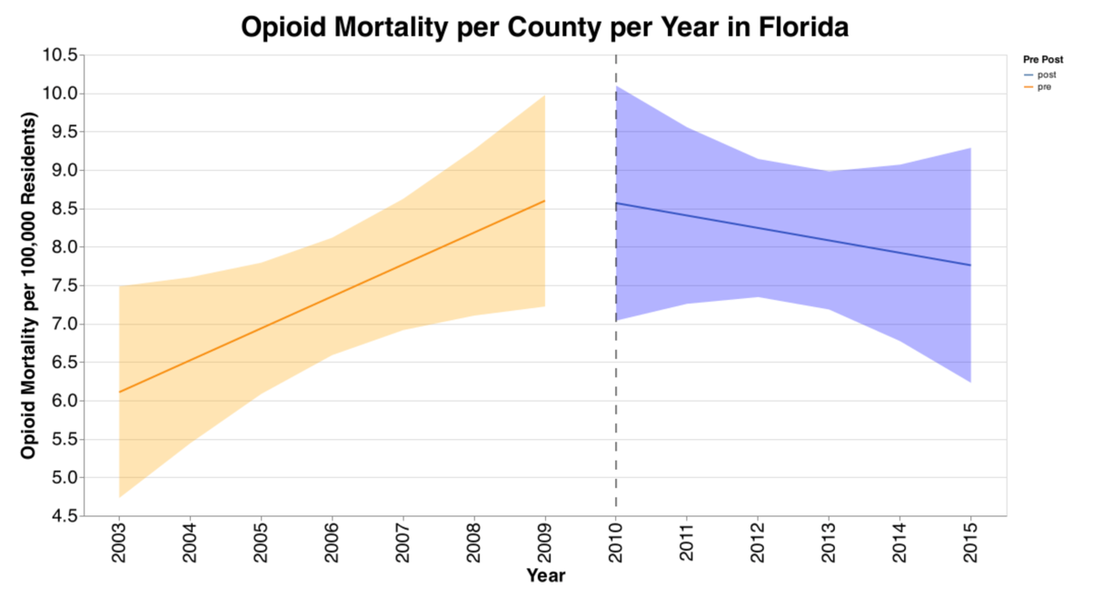

Figure 1 opioid mortality per county per year in Florida

Figure 2 opioid shipments per county per year in Florida

Interestingly, there is a clear increasing trend in both opioid shipments and opioid mortality before 2010, which is reversed. However, as visualized by the 95% confidence bands, there is more significant uncertainty (i.e., more spread) in the mortality data. This is likely because the vast majority of counties have less than ten opioid mortality deaths per year, which are unreportable and represented as zeros in our dataset. Overall, from these graphs, we can assert relatively confidently that there was a change in the trend of opioid shipments per capita in Florida after the policy change, and mortality also appears to display a different trend. Still, we are less confident due to the more significant error bands.

3.1.2 Texas & Washington Analysis (Mortality)

Next, displayed are opioid mortality trends in Texas and Washington, again, before and after policy changes.

Figure 3 opioid mortality per county per year in Texas

Figure 4 opioid mortality per county per year in Washington

Visibly, the results here are not as clear. There is a step-increasing trend in mortality in Texas before the policy change (2007) and a much flatter trend. While the evidence is not clear enough to say there is a reversal in the trend, the increase is at least dampened. In Washington, on the other hand, there is visibly minimal evidence that the trend in opioid mortality was altered at all after the policy change. While the confidence band is wide, the movement itself is nearly identical.

3.2 Difference-in-Difference Analysis

While the trends above are an important part of the story, the pre-post analysis does not take into account any other confounders that could be happening at a national level, also influencing either opioid shipments or mortality. To account for any potential greater trends that could muddy the interpretation of our results, we also conducted a difference-in-difference analysis (methodology for selecting control states discussed in the XX section). As previously, there are the same four graphs, but in this case, the graphs also include the selected control counties before and after the policy change. Below are graphs for Florida for both mortality and shipment data. The pre-post lines representing Florida are exactly the same as above, but these graphs also contain the selected control counties. Interestingly, the control counties demonstrate that the increasing trend in opioid mortality exhibited before the policy change actually steepens afterward. This directly supports the previous conclusion from the pre-post analysis and even strengthens it.

3.2.1 Florida Analysis (Mortality & Shipment) VS Controls

For Florida's opioid shipment data, the opposite is true. The control states show that the trend in shipments is decreasing outside of Florida, but the reversal of the trend in Florida is still much stronger than that exhibited in the control states.

Figure 5 opioid mortality per county per year in Florida vs. controls

Figure 6 opioid shipment per county per year in Florida vs. controls

3.2.2 Texas & Washington Analysis (Mortality) VS Controls

Similarly, below are the graphs for mortality in Texas and Washington. For Texas, the change in the increasing trend previous to the policy change is much more visible when compared with the control. However, in Washington's graph, interestingly, we see an acceleration in the increases of opioid mortality in the control states. Contrary to our initial pre-post analysis, this suggests that while the trend before and after the policy change in Washington is similar, there actually may be a treatment effect due to overall increases in similar states to Washington. However, this interpretation is similarly limited by the width of the confidence bands, which suggests the data may have widespread, and we are not very confident about the direction of the trend.

Figure 7 opioid mortality per county per year in Texas vs. controls

Figure 8 opioid mortality per county per year in Washington vs. controls

1. **Conclusion**

### 4.1 Discussion

### This study addresses data on opioid lethality and opioid shipments in 3 states between 2005-2018 in regards to the impact of opioid restriction policies after their release. we assessed the effect of these policies to some extent by comparing the variable control states, with the effectiveness of the policies in Florida reflected in a clear downward trend in the data after release. In Washington, Texas, the situation may support the possibility that the bills in these two areas are less effective.

### 4.2 Limitations of the current study

### Given that our learning objective is the mortality and transport of opioids for different counts, we face some limitations. The first is the lack of data. Most of the counts with mortality rates below ten were added as 0 possibly affecting the representation of part of the trend. The limitations of the data are also reflected in the fact that if we want to analyze the effectiveness of policies, it is necessary to include more policy categories to represent. It is clear that policies of different types and intensities are unlikely to have similar results. Comparing shipments, data on whether prescription opioids were used for consumption in institutions such as hospitals could be added to the discussion. In particular, policy and control groups may have different trends in outcomes over time, or the composition of state populations may change significantly over time. While the most common approach is regression adjustment. However, more robust models should be considered to assess.

### The field still faces significant methodological challenges and considerations, including standardized classification of opioid policies, identifying optimal control groups, and tightly controlling for differences between policy and control groups, and identifying variables that better capture the impact of policies. Improving the methodology of opioid policy evaluation studies is critical to the final government being able to implement policies that are most effective in reducing opioid harm.